**Chapter 4**

**Introduction**

As stated earlier we generate required data from the standalone python program with the predictive models and save it as JSON format in file system. We pull the stored data through web API and feed in client-side scripts for drawing charts since uncertainty visualization in the form of CA through various charts is the key part of our research.

The subsequent sections show are major web interfaces and charts which we have implemented in our application and applied chromatic aberration wherever possible.

**4.1 Web Interface**

To visualize different charts, we have developed a web-interface with several html input controls in the top toolbar and all charts are presented in the main container placed just below the toolbar.

Figure-5: Initial Web Interface (Left - Bubble chart, right – Color Streamgraph)

In the following section, we briefly explain the basic functionalities of the input fields in toolbar.

**Chart dropdown**: List of chart names, on selection it will automatically draw the corresponding chart in the main container. Bubble chart, Parallel Coordinates, Horizontal chart, Impact Chart, Usage Chart are available options in the list.

**Model dropdown:** Names of the predictive models for which we have generated data for finding the uncertainties and presenting as chromatic aberration. MLP, CNN, LSTM and ARIMA are the available options for the list.

**Reset:** Return to the initial state of the drawing for bubble chart. For this chart it has different type of modes listed in the right side of the toolbar.

**Texture Stream:** This is a toggle button to switch the stream graph from color-based filling to texture based filling, that means instead of flat color flow it uses bullet like textures to fill the stream but still they have different colors for their own country region. More detail is shown in section 4.5.

The followings are available operational modes of bubble chart:

**Pan Chart:** Since the bubble chart and stream graphare drawn side by side and they work interactively like filtering the streamgraph with the selection from bubble chart, so sometimes it is necessary to zoom-in/out of the charts and consequently panning the charts in its own space is also advantageous.

**Star Fish:** changes the drawing mode to interact with mouse events. In this mode user can click on country bubble to open the corresponding texture stream graph as a wing of star-fish layout. So, when user select 8-10 countries in each side then the resultant chart will look like starfish. We will show further detail about this layout in later sections.

**Drill Models**: In this mode when user selects a country then four stream graphs with aberrated textures are shown in the right panel corresponding to the four predictive models. Detail explanation is shown in later section.

**Bubbles Select:** Select one or more country from the bubble chart and redraw it with the selected countries only. After selection, ‘Go’ button will perform the execution of redrawing task. It helps to compare specific countries because aberrations are not clearly perceivable with all countries.

**Bubbles Remove**: It is opposite feature of bubble select mode. It filters out countries from the bubble chart. In this mode the selected countries are omitted from the chart. After omitting countries on press ‘Go’ button it redraws with the other countries.

**Reshuffle Streams:** Allows to draw main streamgraph with the selected countries of interest from bubble chart. This is handy approach to see the bigger picture and compare streamgraph of one or more countries selectively.

**4.2 Filtering**

We use data for top 100 countries based on the total infection rate. As we see from the Figure-5, it is difficult to read the label of the country and difficult to identify the extent of aberration for the smaller circles having lower uncertainties. That’s why we implement a filtering option with different perspectives. In the section below we briefly explain them.

**4.2.1. Bubble Selection Mode**

Figure-6: With selected countries of interest

In this mode, it allows users to select the countries of interest on first click and toggles on the next one. So, when all preferred countries are selected the ‘Go’ button redraws the bubbles side by side with comparatively bigger sizes.

**4.2.2 Bubble Removal Mode**

Figure-7: Removal of countries of interest

This is the opposite of the earlier one where the user can select the countries to remove from the chart, for instance, removing bigger ones help to find the status of the countries having a smaller size.

**4.3 Legend**

Placed at the top-left corner (Figure-5) just below the toolbar and above the bubble chart with 5 consecutive circles. The circles are drawn for representing 5 different level of chromatic aberrations. The circle with 100% uncertainty represents the maximum uncertainty among all the countries drawn in bubble chart. Therefore, to find the amount of uncertainty for lower uncertainty valued countries, it helps users easier understanding.

**4.4 Reshuffling** **Streamgraph**

In Figure-5 we found the stream graph with countries are a bit clumsy to understand, so reshuffling is important to see and compare them side by with lower number of countries.

Figure-8: Reshuffling main streamgraph

To serve that purpose, in this mode, a user can choose the countries from the bubble chart. On select the countries, the corresponding ones will be highlighted in the streamgraph to represent the selection and the rest of the country-streams will be grayed out in the same chart (left view). Pressing ‘Go’ button confirms the redraw execution streamgraph with the selected countries as shown in the Figure-8 (right side view).

**4.5 Drill-Down for Model Predictions**

Figure-8: Drill-down of streamgraphs for all models

**4.6 Star Fish Inspiration**In this approach, user can draw multiple stream graphs by dynamically calculating the position of the country cell and its corresponding start point in the cell center and angle to place it without (or possibly minimum) overlapping the other countries’ streams. If we call each individual stream as a wing, then the benefit of this chart is it allows one to draw many charts in compact way. Another interesting feature is that we accommodate multiple properties in each stream, for example: mlp, cnn and lstm predictions are used in bottom chart whereas total_cases, new_cases, new_deaths, icu_patients, hosp_patients, new_tests are used for top chart.

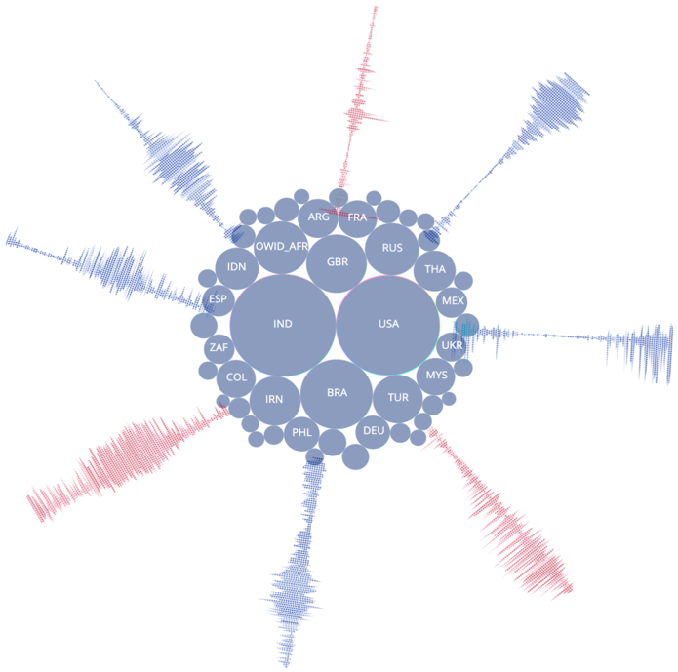

Figure-10: Multi Country Stream Graphs. Color filled (top), CA Texture filled (bottom)

**4.7 Parallel Coordinates Chart**

Parallel plots or parallel coordinates plots allows one to compare the features of several individual observations (series) on a set of numeric variables. Each horizontal axis represents a variable and often has its own scale. The units can be different, that is the strength of this special kind of plots. The main advantage offered by parallel coordinate is the representation of high dimensional data as a 2-dimensional visualization. Data is represented in the form of a polyline, and it becomes possible to perceive trends shown by data entries from the visualization. 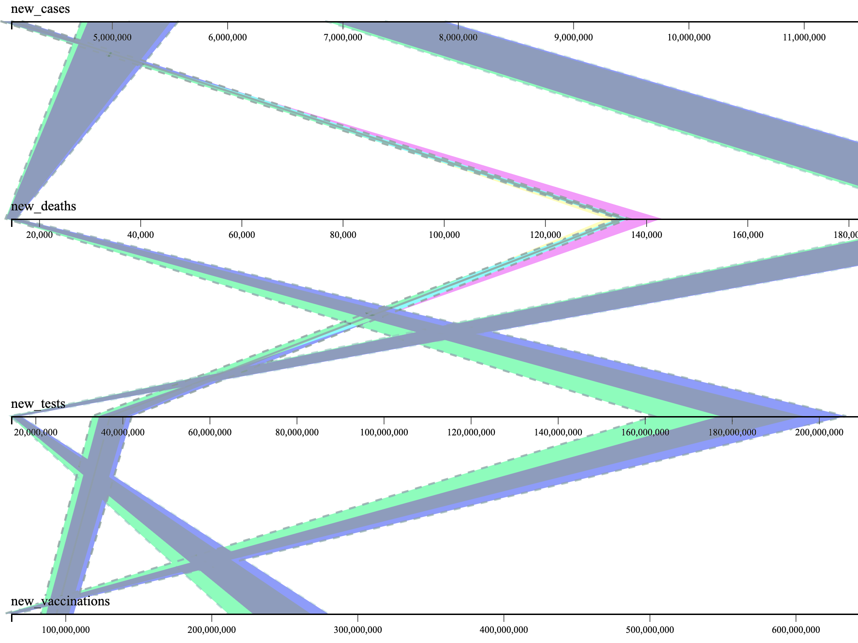

Figure-11: Parallel coordinates chart

This plot is helpful in our presentation because we have several variables together to visualize one after another and showing the relationships between them. For example, you can compare number of total cases(total_cases) with hospitalized patients (hosp_patients) facilitated by a tooltip showing the country name. Also, it can show the predicted flow (thinner line) along with actual counts (thicker line). The limitation of this chart is frequent overlaps for multi-variable and multi-

**4.8 Impact Chart**

This chart helps to indicate daily uncertainty presentation for every country as a cell. In this way a user can perceive trends for certain day or a set of consecutive days. In other words, the chart provides a useful platform that helps you decide which uncertainty requires your attention. So, if this tool was used by WHO then the administrator could consider which countries are vulnerable tomorrow or the day after tomorrow.

Figure-12: Impact chart with CA textures

**4.9 Horizontal Chart**

Horizontal charts are small-multiple area charts that allow greater precision for a given vertical space by using colored bands. These charts can also be used with diverging color scales to differentiate positive and negative values.

Figure-13: Horizontal chart (Color filled – top, CA Texture filled – bottom)

**4.10 Usage Chart**

This chart is more much like impact chart because of their construction style. Both show information for date vs country but in opposite order, that means here horizontal axis represents country and vertical axis represents date.

Figure-14: Charts of Daily counts

4.11 World Map

Figure 15: Uncertainty in World view

Figure 15: Uncertainty in Zoomed area of World Map